# Assignment -4

|  |  |
| --- | --- |
| Assignment Date | 07 October 2022 |
| Student Name | S.SUDHEEKSHAN KUMAR |
| Student Roll Number | 311519104703 |
| Maximum Marks | 2 Marks |

**Ouestion 1:**

1. Pull an Image from docker hub and run it in docker playground

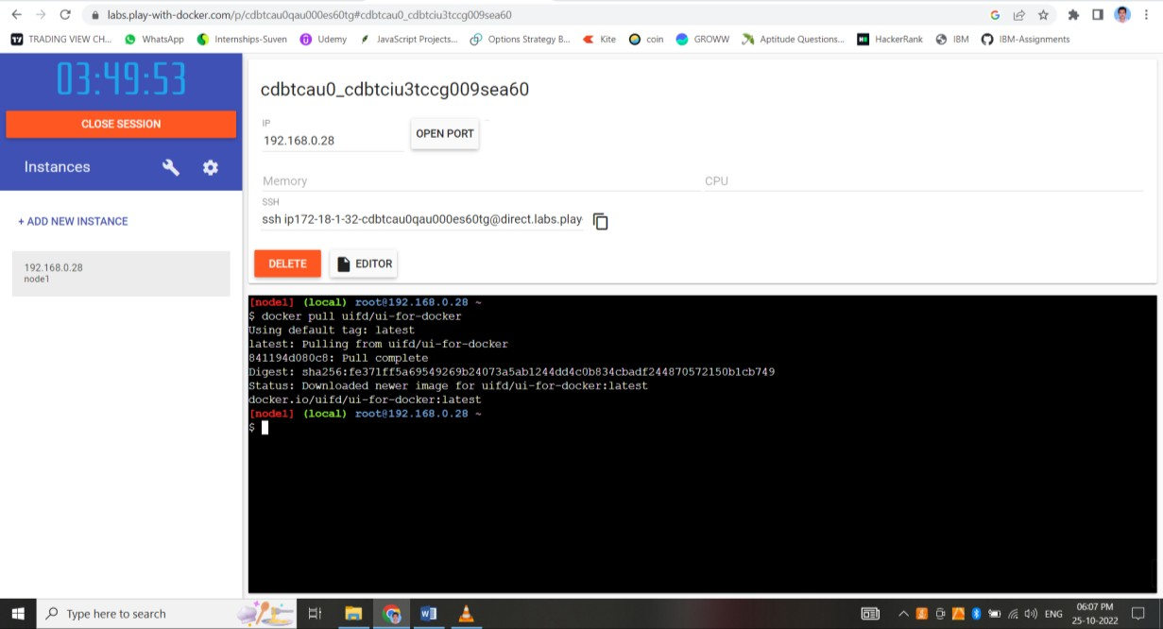

# Ouestion 2:

1. Create a docker file for the jobportal application and deploy it in Docker desktop application.

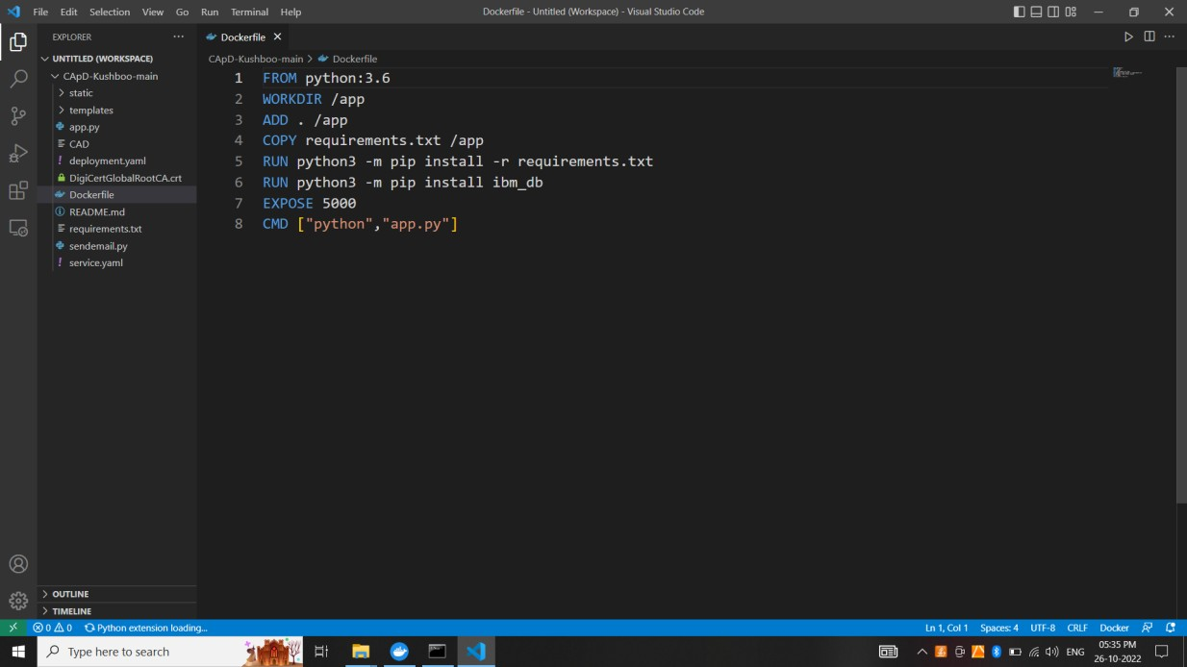

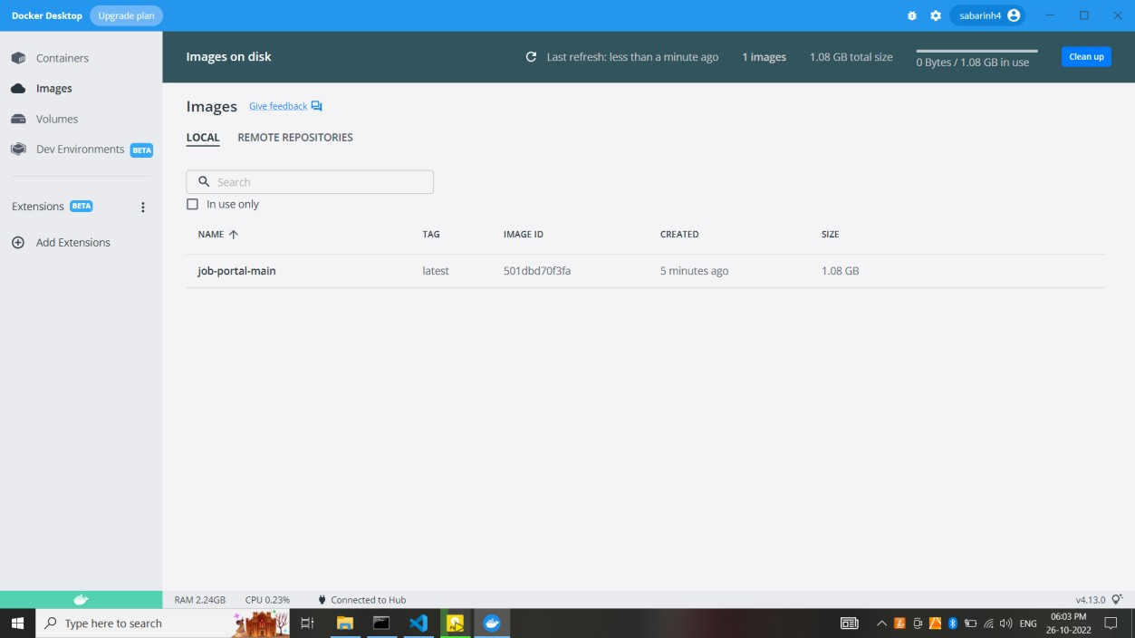

# Ouestion 3:

1. Create a IBM container registry and deploy helloworld app or jobportalapp.

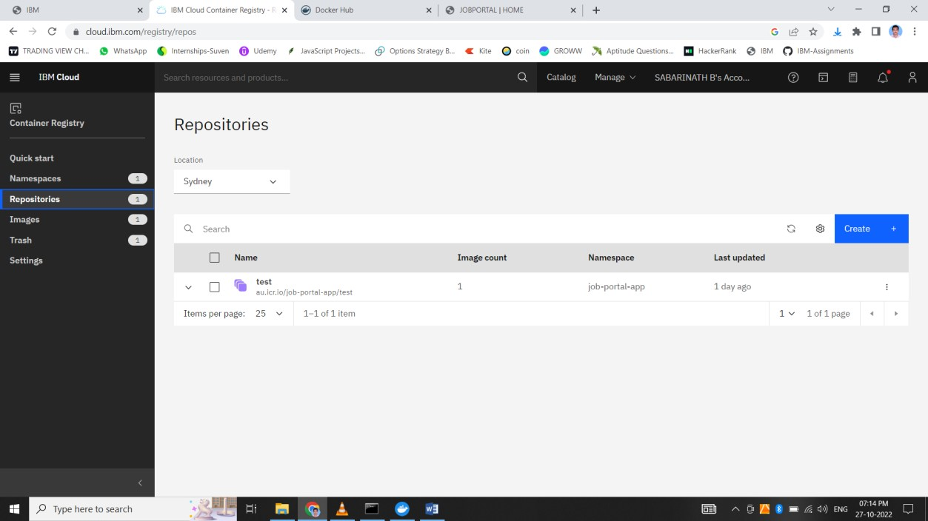

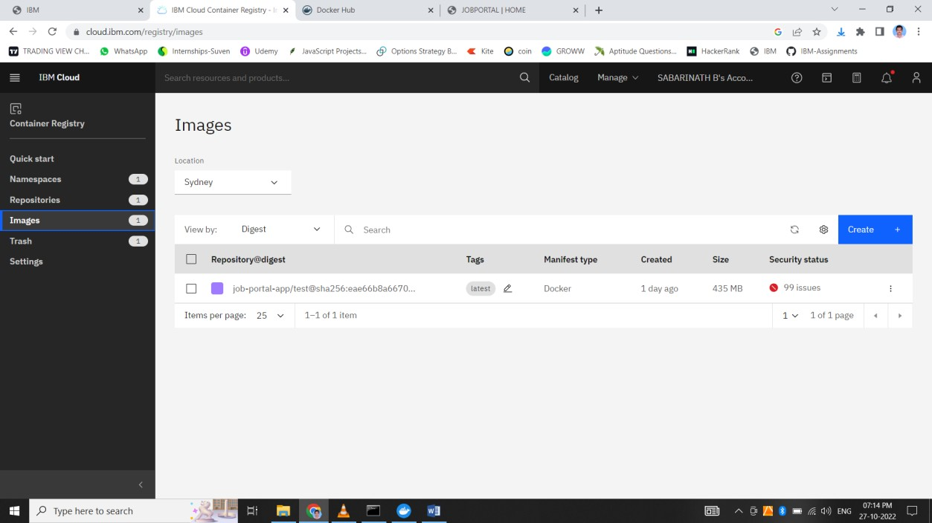

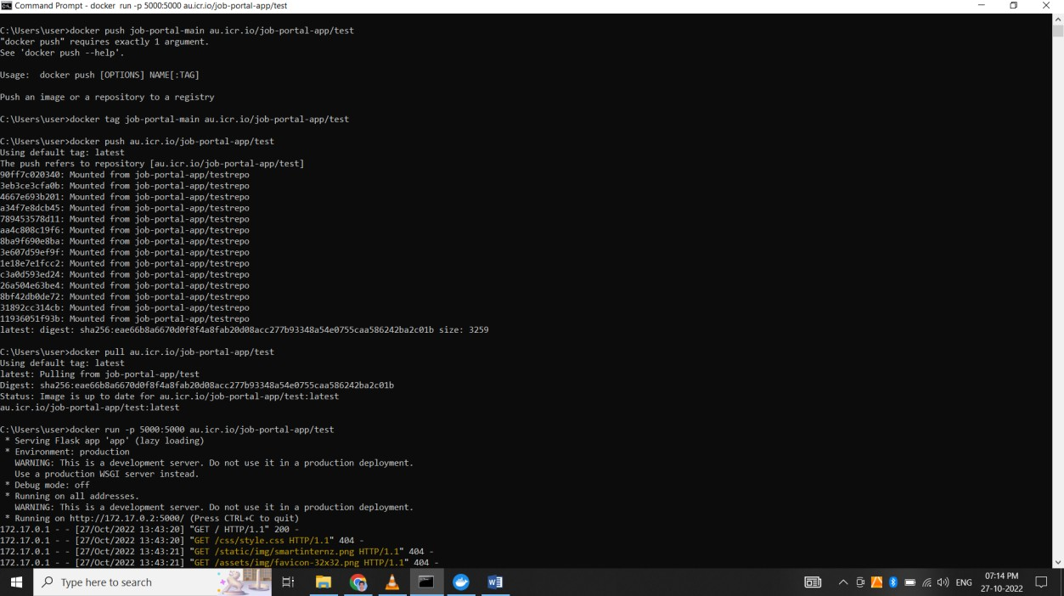

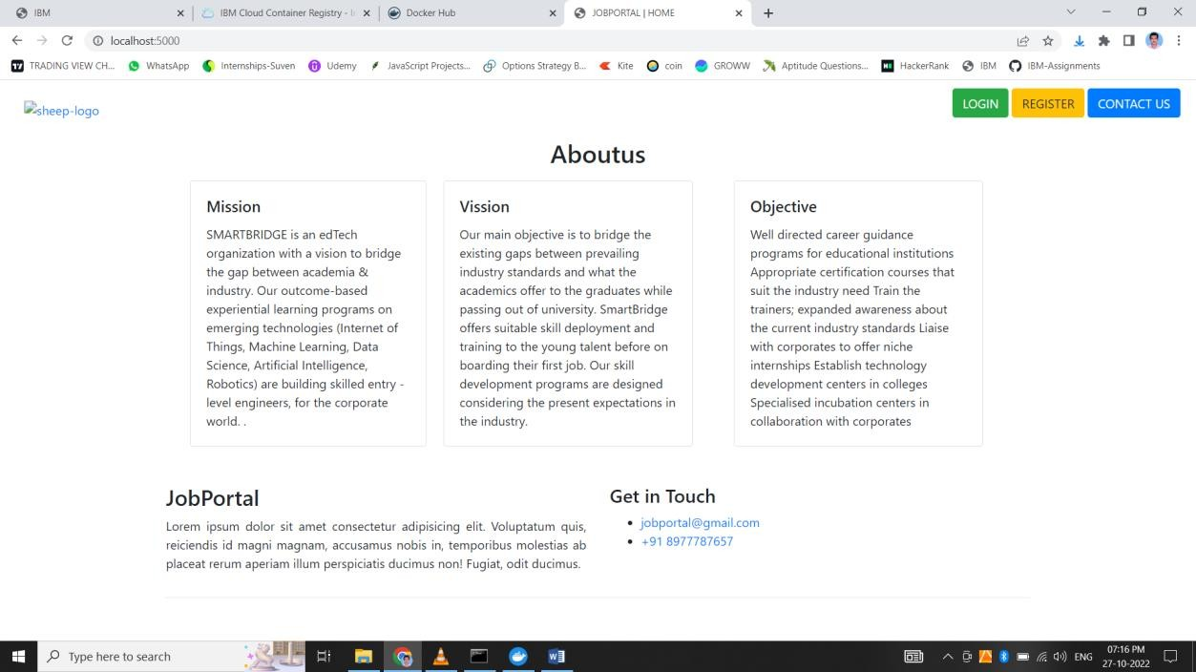

# Ouestion 4:

1. Create a Kubernetes cluster in IBM cloud and deploy helloworld image or jobportal image and also expose the same app to run in nodeport.

